

Mnimi* : Kids Learning App

Project Report



By

|  |  |  |  |
| --- | --- | --- | --- |
| S. # | Roll # | Registration # | Name |
| 1 | 14 | 11710794 | M Harshavardhan Reddy |
| 2 | 40 | 11715695 | S Ashish Kumar |
| 3 | 54 | 11715698 | Himmat Singh Rajput |

Section: K17WP



**School of Computer Science and Engineering**

Lovely Professional University

Phagwara, Punjab (India)

* Mnimi is Greek word for memory

Table of Contents

Table of Contents 1

1.Introduction 2

2.Objective………………………………………………..……………………………………..2

3.User Group 2

4.Overall Description 2

5.Platforms Used 3

6.Snapshots 3

7.Benifits 6

1. **INTRODUCTION**
2. 
3. reading ability and understanding of any child depends on the training and background
4. upon which the child is laid on. This now matters for parents to invest more time and
5. money on materials and tools that can help their little kids to gain knowledge and
6. become successful in the future education and profession.
7. In the early days, teaching and learning were more formal and being conducted
8.               
9. has changed (Agudo, et al., 2010). Learning and teaching materials has shifted from the
10. black board to more sophisticated gadgets that supports teaching and learning at any
11. level of learning, starting from the preschool to the higher learning. Therefore, there has
12. been a lot of home schooling for kids due to the dynamic approach of teaching and
13. learning in recent years.
14. Agudo et al. (2010) in their preliminary study with preschool kids dictated that
15. kids face some difficulties in their interaction with the mouse while playing computer
16. games. Double click and any interaction leading to dragging the cursor is difficult for
17. kids as it requires more complex psychomotor abilities.
18. 
19. reading ability and understanding of any child depends on the training and background
20. upon which the child is laid on. This now matters for parents to invest more time and
21. money on materials and tools that can help their little kids to gain knowledge and
22. become successful in the future education and profession.
23. In the early days, teaching and learning were more formal and being conducted
24.               
25. has changed (Agudo, et al., 2010). Learning and teaching materials has shifted from the
26. black board to more sophisticated gadgets that supports teaching and learning at any
27. level of learning, starting from the preschool to the higher learning. Therefore, there has
28. been a lot of home schooling for kids due to the dynamic approach of teaching and
29. learning in recent years.
30. Agudo et al. (2010) in their preliminary study with preschool kids dictated that
31. kids face some difficulties in their interaction with the mouse while playing computer
32. games. Double click and any interaction leading to dragging the cursor is difficult for
33. kids as it requires more complex psychomotor abilities.

Preschool age is critical for Kid’s development. A good reading ability and memory of any child depends on training. In early days, teaching and learning was more formal and being conducted in classrooms; but due to rapid growth in technology today, kid’s way of learning has changed. Learning and teaching materials has shifted from the black board to more sophisticated gadgets that supports teaching and learning at any level.

Mnimi is one such application aimed to aid kids learning the fun way and in process giving regular and required practice to their brains to develop and enhance their memory skills.

1. **Objective**

To design and develop a functional application but yet simple that is able to focus on kids understating. To improve the efficiency of learning.

To allow kids to practice and enhance their memory.

1. **User Group**

This application is mainly aimed for kid’s below age 7, but it’s simple and elegant design allows all age groups to use it.

1. **Overall Description**

The application is based on image and numbers recognition. Once the user has logged in he/she would have the window display namely two categories: Numbers and Pictures.

User will then have to identify the correct Picture or Number displayed by selecting the correct option. If he/she selects the correct image or number, message is displayed saying it is correct and the images and numbers are shuffled with every next move. If he/she selects the incorrect image or number then a message is popped saying it is incorrect and try again.

1. **Platforms Used**

* Sublime Text 3
* IDLE : Python 3

1. **Snapshots**

* Login Window

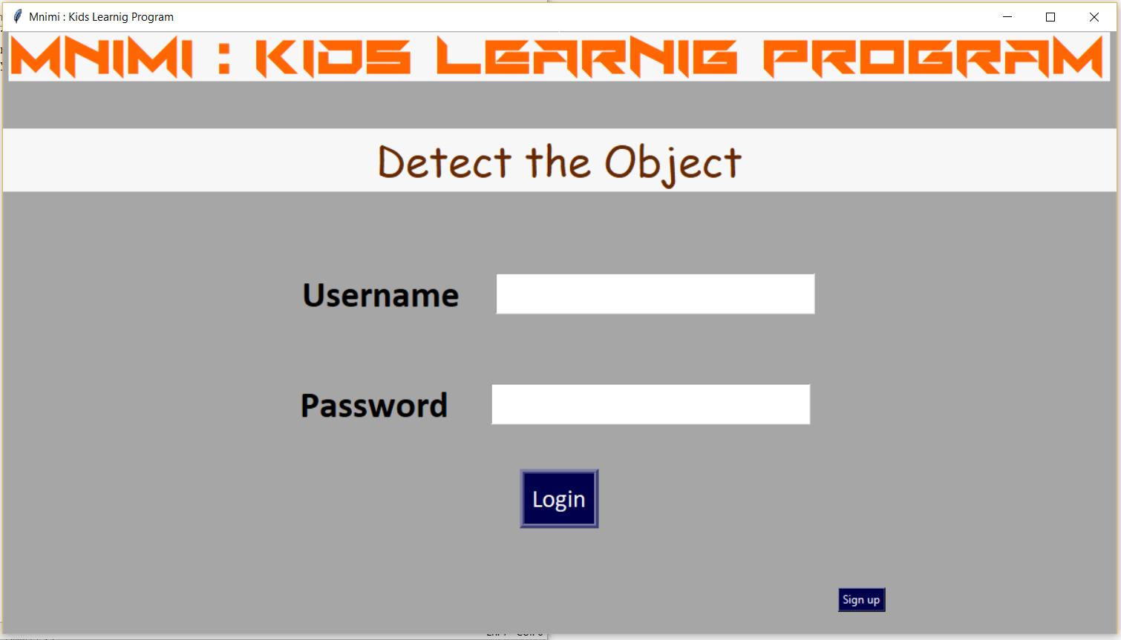

* Sign Up Window
* Categories Window

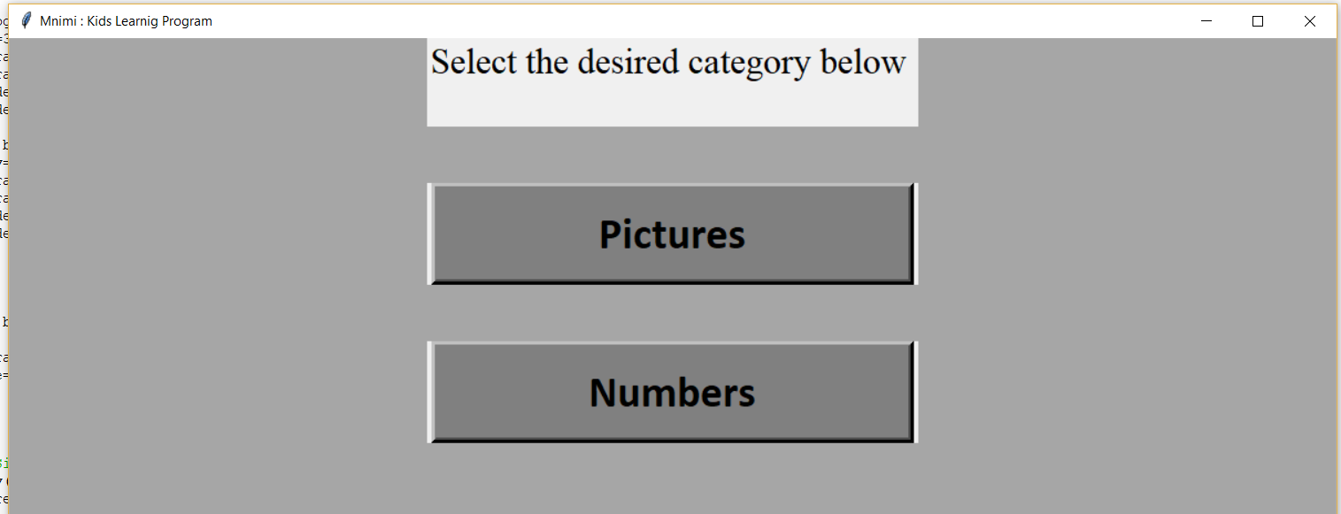

* Numbers Window

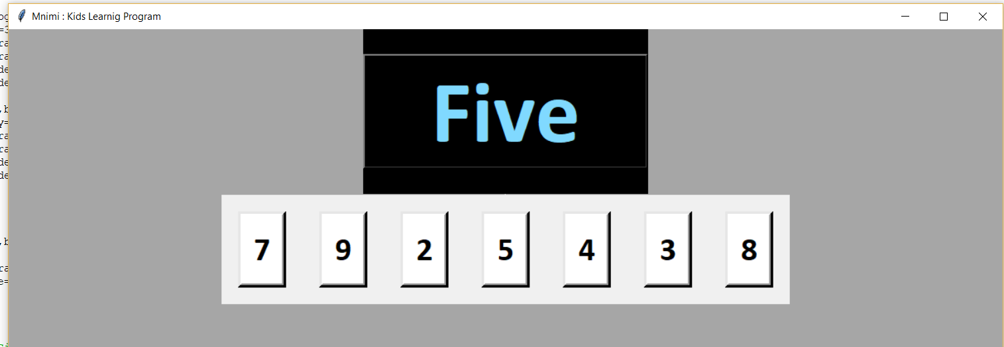

* Pictures Window

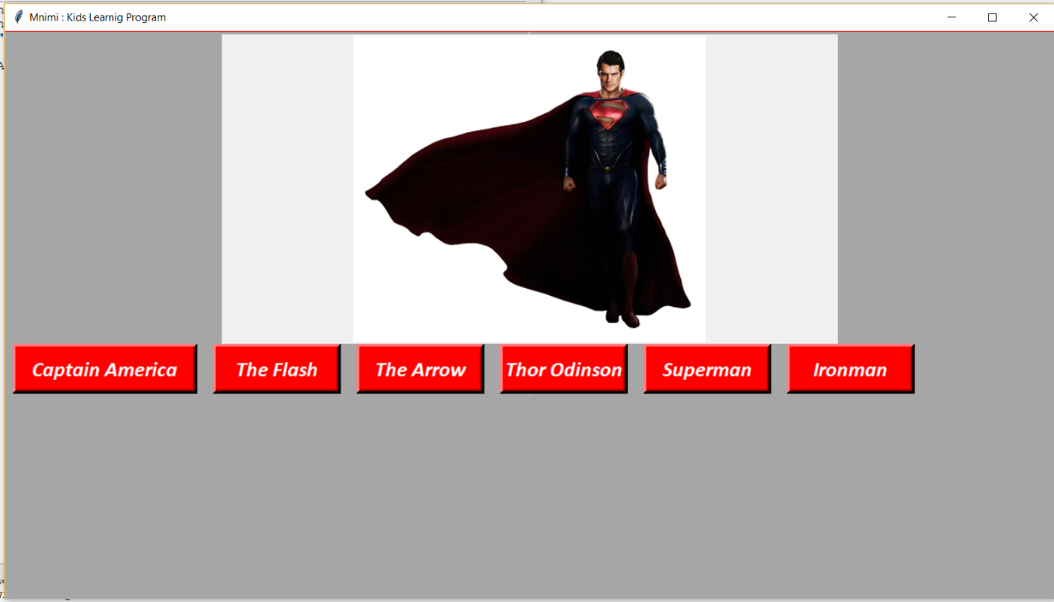

* Correct Selection

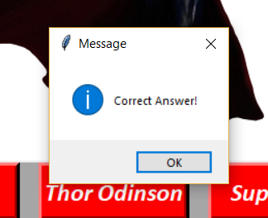

* Incorrect Selection



1. **Benefits**

* **Increases A Child’s Memory Capacity**

Games often revolve around the utilization of memorization  This not only relates to games whereby children have to remember aspects in order to solve the game, memorize critical sequences, or track narrative elements.

* **Computer & Simulation Fluency**

This is something which is very important because we live in a world which is dominated by technology. Playing on games via the internet or offline allows children the license to get used to how a computer works and thus it becomes second nature to them.

* **Helps With Fast Strategic Thinking & Problem-Solving**

Most games require children to think quickly. Moreover, they have to utilize their logic in order to think three steps ahead in order to solve problems and complete levels. This is great because it is something which helps children in later life as they develop their logic, their accuracy and their ability to think on their feet and outside of the box.

* **Develops Hand-Eye Coordination**

Games that require children to use a gamepad or a keyboard and the mouse to operate the games can help develop hand-eye coordination. Not only does this get them more tuned to how a computer works, but it also helps to develop hand-eye coordination because children have to look at the action on the screen whilst using their hands to control what is happening at the same time.

* **Beneficial Specifically For Children With Attention Disorders**

Research has revealed that games can actually help children who experience attention disorders.

* **Skill-Building**

A lot of games contain certain aspects which help children with specific skills.

1. 